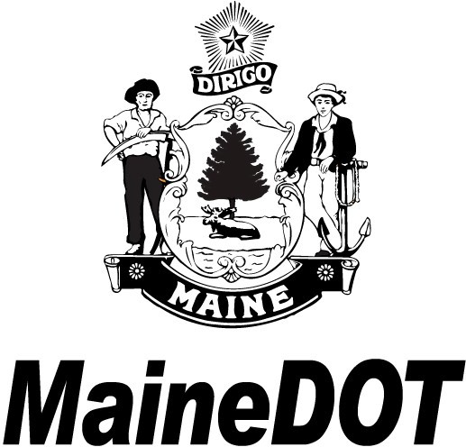
Notice of Formal On-Demand PUBLIC MEETING
Town of PERU

Traffic signal at intersection of Route 108 and Main Street
MaineDOT invites you to attend an on-demand public meeting to provide information about the proposed project. This can be viewed at any time during the formal comment period and allows for online comments and questions that will be answered by MaineDOT staff. The formal comment period will last from 06/05/2026 to 06/24/2026.
Questions, comments, or inquiries can be made at the on-demand meeting or directed to the Project Manager below.
Michael Laberge, Project Manager Maine Department of Transportation,
Multimodal Program
24 Child Street, 16 State House Station, M Augusta, Maine 04333-0016.

Telephone: 207-557-2443 Email: Michael.Laberge@maine.gov

Access to the Peru project and other active meeting presentations is available on our Public Meetings Page at bit.ly/mainedot-meetings. You can also access those meetings using the QR Code to the right.


For more information regarding MaineDOT Public Involvement, including meeting accessibility and available accommodations you may request for all types of meetings, please see the link to our Background Information page. bit.ly/background-publicinvolvement. You can access that page using the QR Code to the left.

Work Identification Number 029368.00

